Software Design Document
for
RecruitMe Enterprise Application
Version 4.0
Prepared by Ganith Perera, Naduni Pulsarani
RecruitMe
05/10/2017
Version  # | Implemented  By | Revision  Date | Approved  By | Approval  Date | Reason
1.0 | Ganith Perera  Naduni Pulsarani | 01/05/2017 | Ganith Perera  Naduni Pulsarani | 04/05/2017 | Initial DocumentIEEE Software Requirements Specification Template
2.0 | Ganith Perera  Naduni Pulsarani | 05-05-2017 | Ganith Perera  Naduni Pulsarani | 07-05-2017 | Further Details for Use Case Diagram
3.0 | Ganith Perera  Naduni Pulsarani | 08-05-2017 | Ganith Perera  Naduni Pulsarani | 08-05-2017 | Further Details for Activity Diagrams
4.0 | Ganith Perera  Naduni Pulsarani | 09-05-2017 | Ganith Perera  Naduni Pulsarani | 10-05-2017 | Review & finalized
VERSION HISTORY

Table of Contents
Table of Contents 2
1. Introduction 3
1.1 Purpose 3
1.2 Scope 3
2. Use Cases 3
3. Activity Diagram 5
3.1 Activity Diagram for the User Login 6
3.2 Activity Diagram for the User Registration 7
3.3 Activity Diagram for the Update Profile 8
3.4 Activity Diagram for the View and Search Queries 8
4. Class Diagram 8
5. Entity Relationship Diagram 8

Introduction
This is the documentation for the Software Design which will be used to support in Software Development by providing all the details for how the software should be built. Software design document represent the graphical side of the software design for the project of RecruitMe and this is including Activity Diagrams, Use case Diagram, Class Diagrams and other supporting requirement information.

Purpose
This document’s purpose is to provide a description of the design of a system which is going to be developed. This is also with fully enough for Software Development to proceed with an understanding of the software which is to be going to develop.

Scope
Software Design Document which is for a base level system and this will work as a proof of concept for the use of building a system and provide a base level of functionality to show feasibility for large scale of productions.

Use Cases
A use case diagram describes a set of sequences in which each sequence indicates the relation with outside things. A use case involves the interactions of actor and system. Use case diagram can be used during analysis to capture the system requirements and to understand how the system should work. During the design phase, you can use use-case diagram to specify the behavior of the system as implemented.
A use case diagram contains actors, use cases, interactions and system boundaries. An actor represents a user and use case are a top-level representation of the intended functionality of the system.
With regard to the RecruitMe application there are three main user categories. They are,
- Job Seeker
- Recruiter
- System Administrator

We can identify the overall use case diagram for the system that describes the modules of the system which shows, which each module does and interactions with each other modules(Component).

Below is the Use Case Diagram for RecruitMe Application
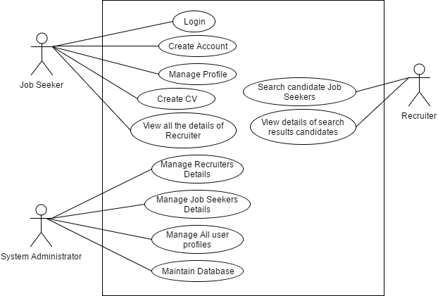

Activity Diagram
Activity diagram is usually used for modelling the logic captured in a particular use case in a use case diagram. Activity diagram can also be used to model a specific Actor’s workflow within the entire system. Activity diagram can also be used independent of use cases for other purposes such as to model business process of a system, to model detailed logic of business rules etc. activity diagram shows all potential sequence flow in an activity.

The design of the RecruitMe is presented in four activity diagrams that how the activity flow is carried out.

Activity Diagram for the User Login
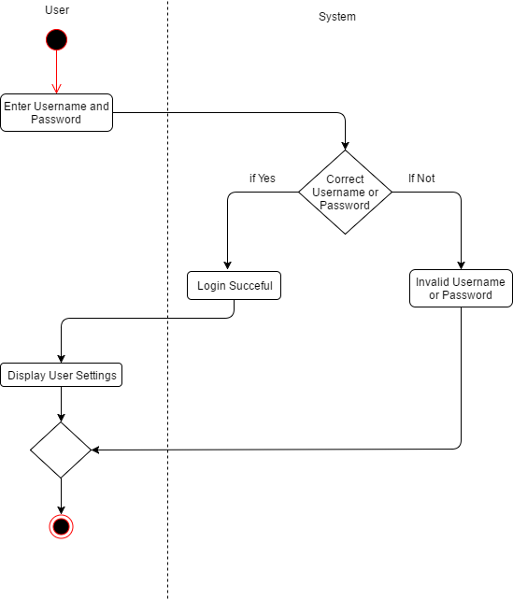

Activity Diagram for the User Registration

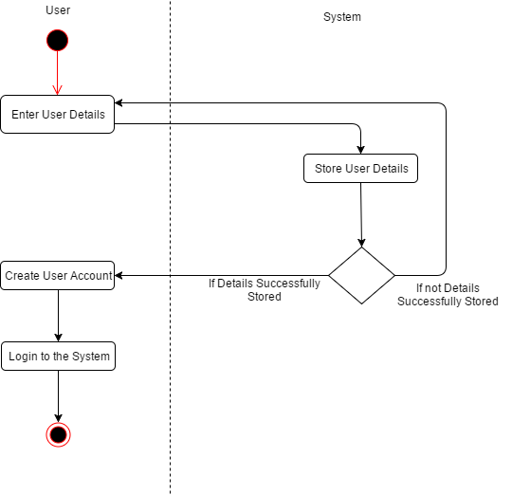

Activity Diagram for the Update Profile

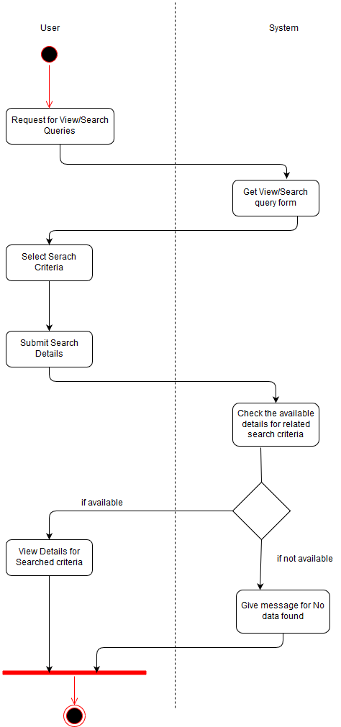
Activity Diagram for the View and Search Queries

Class Diagram
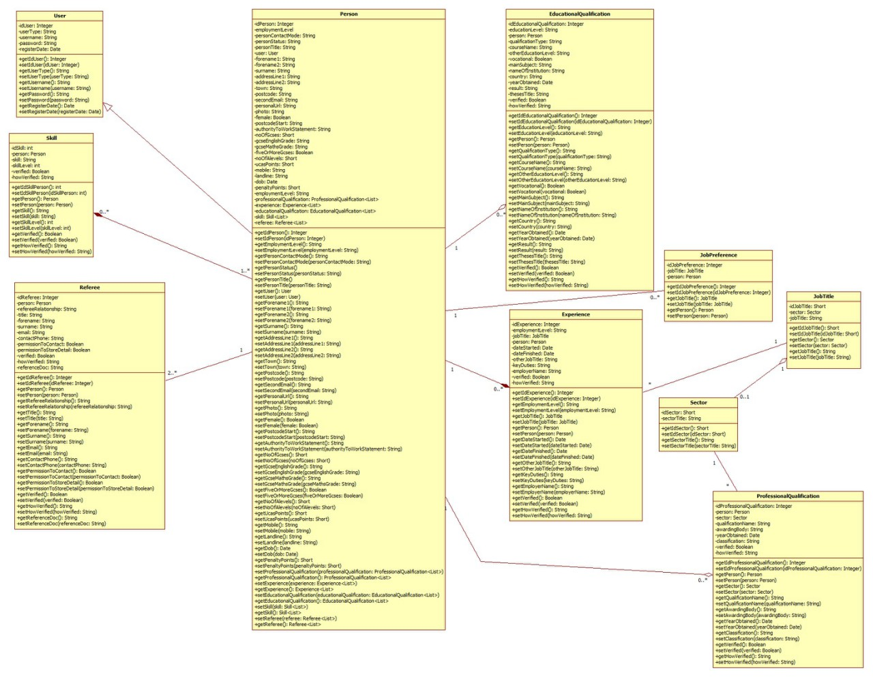
UML class diagram is used to model the structural aspects of the system; i.e. classes and its attributes (Fields) and operations (methods) and also the interrelationships (association, composition, aggregation and generalization) between the classes.

Entity Relationship Diagram
Entity model is a conceptual data model that view the real world as entities and relationships. A basic component of the model is the Entity- Relationship diagram which is used to visually represent data objects. ER diagram uses basic constructs such as entities, attributes and relationships.

Physical Schema
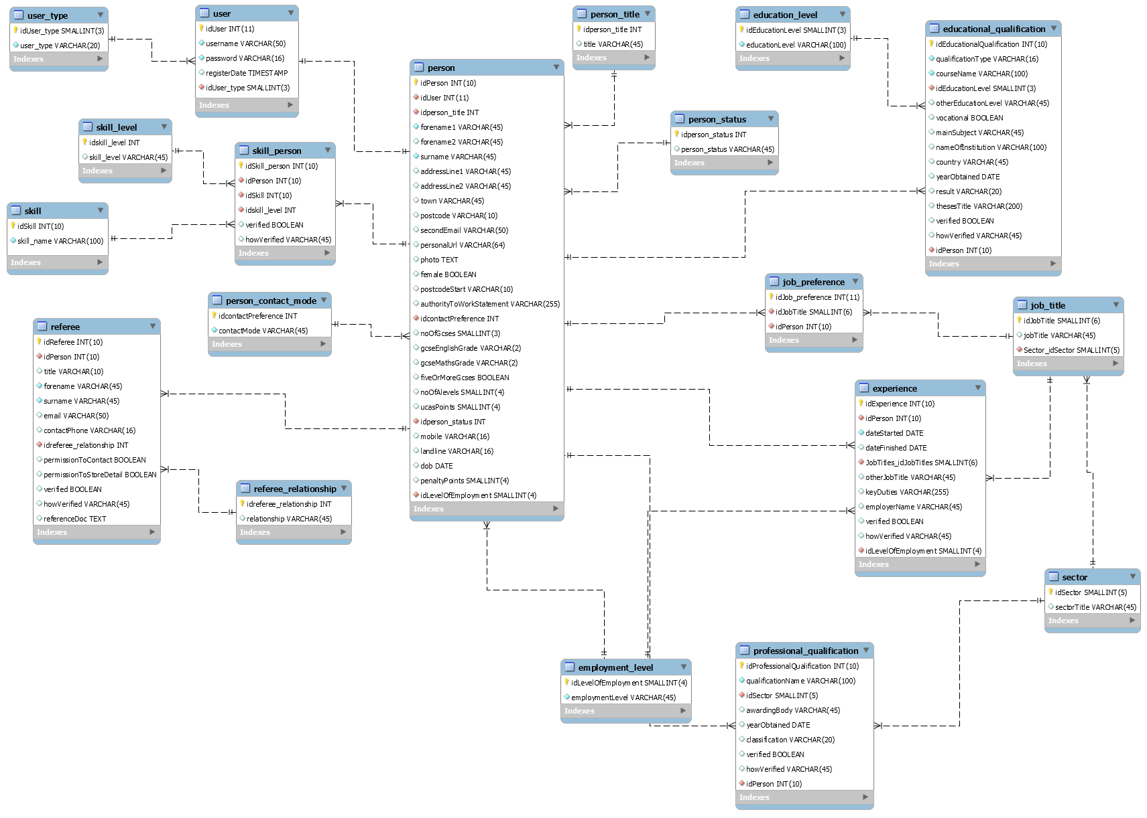

Conceptual Schema
